**Fredio Pratama Dimyati**

**Fullstack Website Portfolio**

**Departemen Pengelolaan Sistem Informasi**

**[Tahun Penerbitan]**

Table of contents

Important Information 6

1 Create New Folder 7

1.1 Folder for Back End 7

1.2 Folder for Front End 7

2 Setup Dependencies General 8

2.1 Install Chocolatey 8

2.2 Install NodeJS 9

2.3 Install Sanity Global 11

2.4 Install React 11

2.5 Install TailwindCSS 12

3 Setup Dependencies BackEnd 13

3.1 Register Sanity Account 13

3.2 Create Project on Sanity 14

3.3 Install Project on Our Local 15

3.4 Test Project on Our Local 18

3.5 Test After Project on Our Local 19

4 Setup BackEnd Sanity 19

4.1 Create Testimonial 19

4.2 Create About 19

4.3 Create Brands 20

4.4 Create Contact 20

4.5 Create Experiences 21

4.6 Create Skills 21

4.7 Create Work Experience 22

4.8 Create Work 22

4.9 Edit Index 23

4.10 Test Our Back End 23

5 Setup Dependencies FrontEnd 24

5.1 Install React 24

5.2 Add Extension VSCode 25

5.3 App.Js 26

5.4 Index.Css 27

5.5 Install Python 27

5.6 Install Visual Studio 29

5.7 Setup Path Visual Studio Env 30

5.8 Install Pip Setup Tools 32

5.9 Install Additional Packages 32

6 Create Folder Structure 33

6.1 Structure 4 Folder 33

6.2 Structure Folder Container 33

6.2.1 About 33

6.2.2 Footer 34

6.2.3 Header 34

6.2.4 Skills 35

6.2.5 Testimonial 35

6.2.6 Work 35

6.2.7 Index 36

6.2.8 App 36

6.3 Structure Folder Components 36

6.3.1 Navbar 36

6.3.2 Index 37

6.3.3 App 37

6.3.4 Test Our FrontEnd 37

7 Navbar 38

7.1 Images 38

7.1.1 Navbar 38

7.1.2 Assets 38

7.2 Constant 38

7.2.1 Images.Js 38

7.2.2 Index.Js 40

7.2.3 Test Our FrontEnd 40

7.3 Component 40

7.3.1 Navbar.Jsx 40

7.3.2 Navbar.Scss 41

7.3.3 NavigationDots.Jsx 44

7.3.4 SocialMedia.Jsx 45

7.3.5 Test Our FrontEnd 45

8 Header 46

8.1 Header 46

8.1.1 Header.Jsx 46

8.1.2 Header.Scss 47

8.2 Wrapper 50

8.2.1 Folder Wrapper 50

8.2.2 AppWrap.Js 51

8.2.3 MotionWrap.Js 51

8.2.4 Index.Js 51

8.2.5 Test Our FrontEnd 52

9 About 52

9.1 Client 52

9.1.1 Client.Js 52

9.2 About 52

9.2.1 About.Jsx 52

9.2.2 About.Scss 53

10 Client Sanity 54

10.1 Client 54

10.1.1 Token Api Sanity 54

10.1.2 .Env 56

10.2 Test Application 57

10.2.1 Test Our Backend 57

10.2.2 Test Our FrontEnd 58

11 High Order Component 58

11.1 Social Media 58

11.1.1 SocialMedia.Jsx 58

11.1.2 NavigationDots.Jsx 59

11.1.3 Index.Js 59

12 Work 59

12.1 Work 59

12.1.1 Work.Jsx 59

12.1.2 Work.Scss 61

12.2 Test Application 64

12.2.1 Test Our Backend 64

12.2.2 Test Our FrontEnd 65

13 Skills 65

13.1 Skills 65

13.1.1 Skills.Jsx 65

13.1.2 Skills.Scss 67

13.2 Test Application 70

13.2.1 Test Our Backend 70

13.2.2 Test Our FrontEnd 71

14 Testimonial 71

14.1 Testimonial 71

14.1.1 Testimonial.Jsx 71

14.1.2 Testimonial.Scss 73

14.2 Test Application 76

14.2.1 Test Our Backend 76

14.2.2 Test Our FrontEnd 77

15 Contact 78

15.1 Contact 78

15.1.1 Footer.Jsx 78

15.1.2 Contact.Scss 79

15.2 Test Application 82

15.2.1 Test Our Backend 82

15.2.2 Test Our FrontEnd 82

16 Deploy On Netlify 83

16.1 Setup Frontend 83

16.1.1 Build In Local 83

16.1.2 Upload To Netlify 84

16.2 Setup Backend 85

16.2.1 Domain and CORS 85

# Important Information

This page will shown maximum observability if you try like this

1. Choos tab View, then checklist Navigation Pane

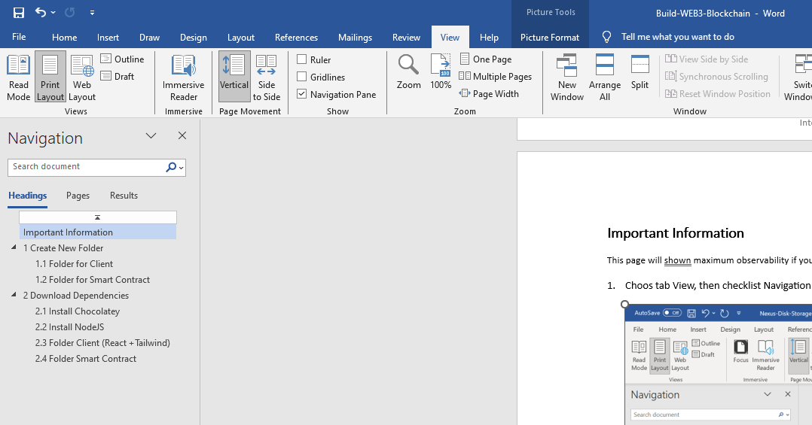

1. Then you will see like following picture

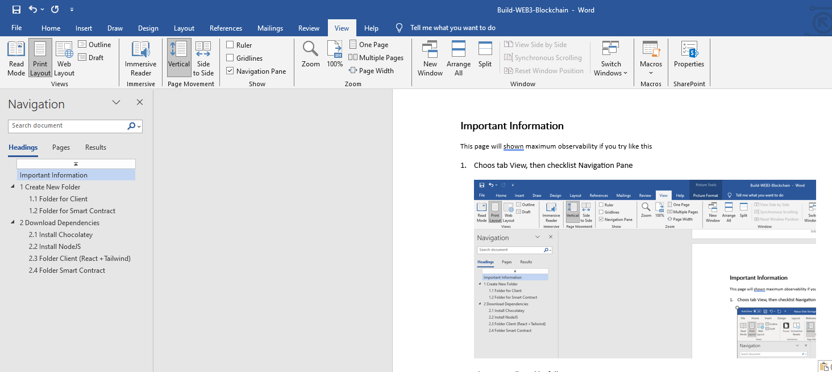

# Questionare

2025 Cloud Support Engineer Questionnaire

## Non-Technical Questions

1. We work remotely (WFH), but we are looking for candidates who are based in Java Island, Indonesia, to help with accommodation arrangements. This includes providing work-related peripherals and organizing occasional team gatherings. Which province in Java will you be working from?
2. Our employment is currently full-time (5 days a week, 8 hours per day). Would you be able to meet this requirement?
3. Our teams in the U.S. and Indonesia collaborate directly without any barriers. Could you share your experience with communicating in English in a professional setting?
4. Why are you looking for new job opportunities? Also, what qualities or characteristics do you value most in your ideal company?
5. To streamline the process, here is our **gross** salary range:

* **Junior Support Engineer:** Starting from 11.5 million IDR
* **Support Engineer:** Starting from 17 million IDR
* **Lead Support Engineer:** Starting from 23 million IDR
  1. Does this salary range meet your expectations?
  2. If the range does not align with your expectations, could you provide your salary expectation along with the reasoning? This information will help us understand your needs and depending on your performance on your interview, we could be flexible.
  3. Are you willing to proceed to the next step of the recruitment process? If not, you may still submit your current information including your salary expectations, without completing the essay. We will retain this data for future recruitment planning and budgeting purposes.

## Essay

As part of our selection process, we would like you to submit a detailed essay (1–2 pages) outlining your professional experience and approach in DevOps. This essay should reflect your real-world involvement with monitoring high-priority systems for performance and reliability, maintaining, deploying, and scaling cloud- based infrastructure. If applicable, feel free to also include any experience you have with designing infrastructure solutions.

We’re particularly interested in learning how you’ve applied DevOps principles to ensure high availability, fault tolerance, security, automation, and collaboration across development and operations. Please highlight your experience with cloud platforms, containerization, infrastructure as code, monitoring, scripting/automation, and cost optimization. Additionally, we’d like to hear about how you handle challenges such as system failures, service outages, or security incidents, and how you collaborate with both technical and non-technical teams.

We also encourage you to include a high-level architecture diagram to illustrate one of your past projects or infrastructure solutions. A visual overview can provide valuable context and help us better understand how you think about systems and design.

We value integrity, clarity, depth, and relevance to what you’ve *actually done* on the job, not just what you know in theory. We want to hear *your story*, **in your own words**. Please don’t worry about perfect grammar or polished language—minor errors are completely okay. In fact, we’d much rather read something that genuinely reflects *you* than something overly refined or generated by AI. What matters most to us is authenticity and insight into how *you personally* think, work, and solve problems. Your submission will help us better understand your fit for our team and how you approach DevOps in real-world scenarios.

# Answer Non-Technical Questions

## Install Chocolatey

Open this website

https://chocolatey.org/install

Open powershell as an administrator, then use this command

**Get-ExecutionPolicy  
Set-ExecutionPolicy AllSigned  
Set-ExecutionPolicy Bypass -Scope Process**

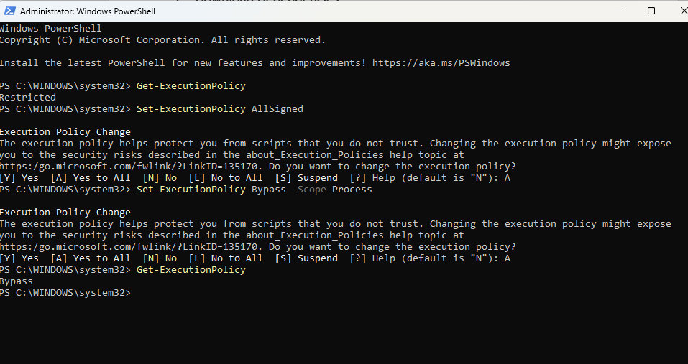

Then run this command to download chocolatey

Set-ExecutionPolicy Bypass -Scope Process -Force; [System.Net.ServicePointManager]::SecurityProtocol = [System.Net.ServicePointManager]::SecurityProtocol -bor 3072; iex ((New-Object System.Net.WebClient).DownloadString('https://community.chocolatey.org/install.ps1'))

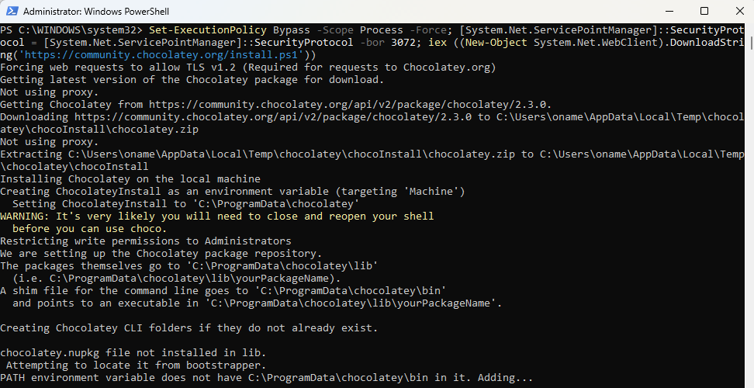

If don’t see any error check version Choco with this command

**choco -?**

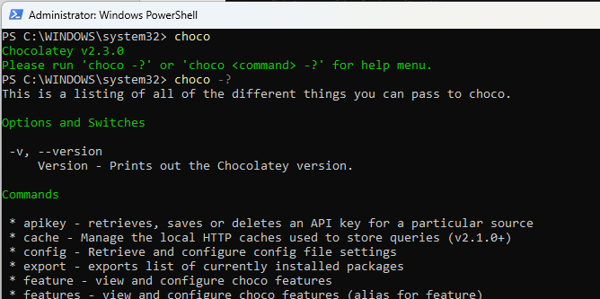

## Install NodeJS

We will install NodeJS using **chocolatey**, then open this website

https://nodejs.org/en/download/package-manager

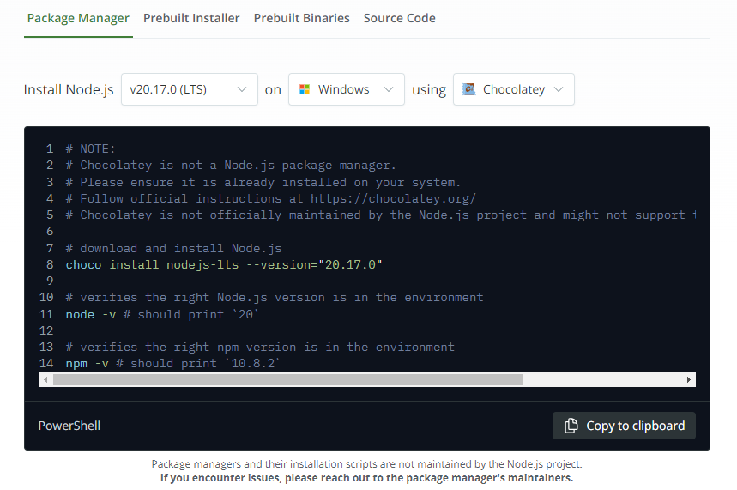

Open powershell as an administrator, then use this command

choco install nodejs-lts --version="20.17.0"  
node -v  
npm -v

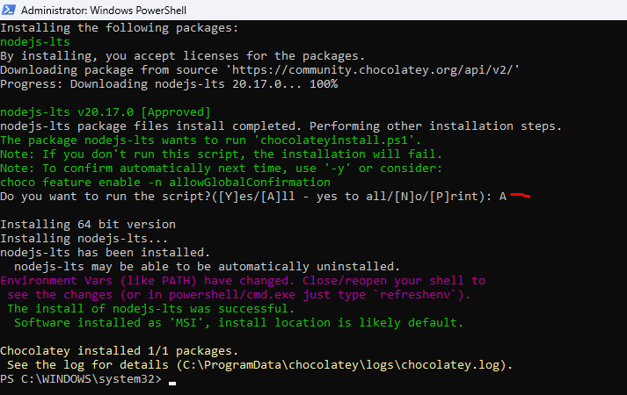

Then install as global so that we can access npm everywhere

npm install -g npm

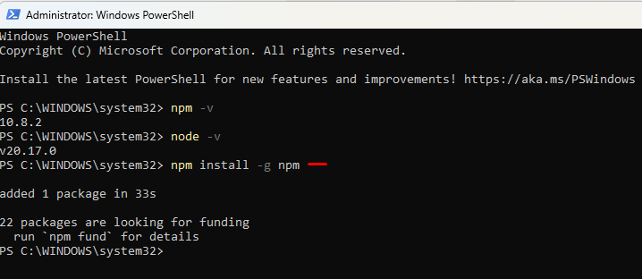

Close Visual Studio Code and open it again, so that we can detect our **npm** in VS Code

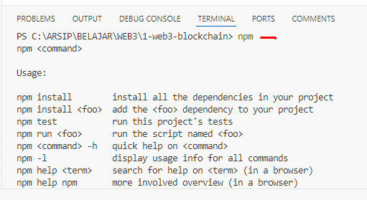

## Install Sanity Global

We will install **Sanity** as global in our local, run this command

npm install –-global @sanity/cli

## Install React

Enter folder **client,** Then paste this command

cd .\client\  
npm init vite@latest

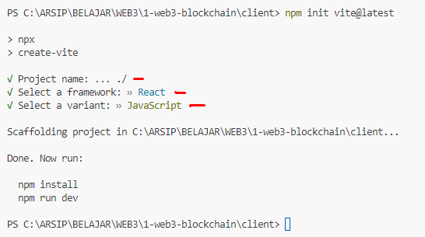

Then run it

cd .\client\  
npm install  
npm run dev

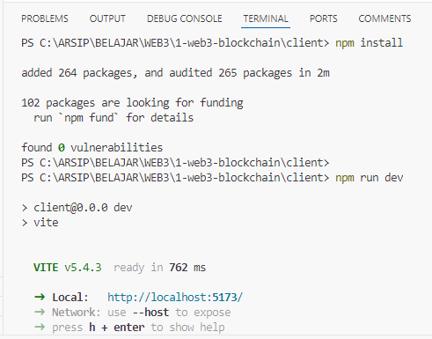

Then open **http://localhost:5173/**

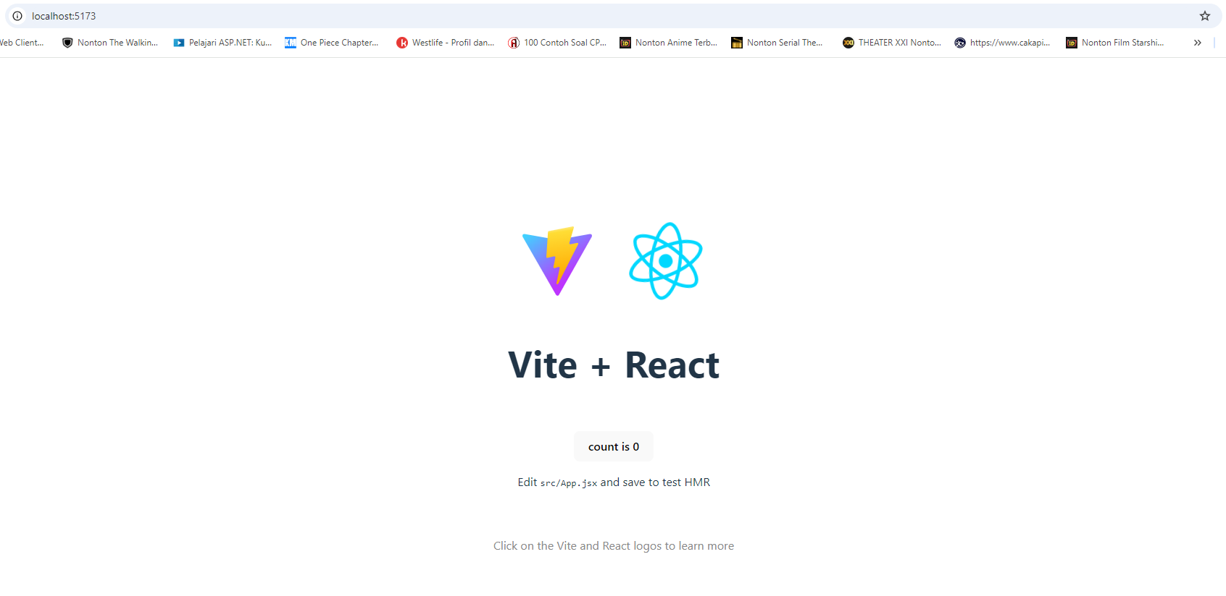

## Install TailwindCSS

Enter folder **client,** Then paste this command

# Create Folder Structure

## Structure 4 Folder

Then we need fill our folder Container

Enter **frontend_react/src,** and create folder inside it

**Assets, Components, Constants, Container**

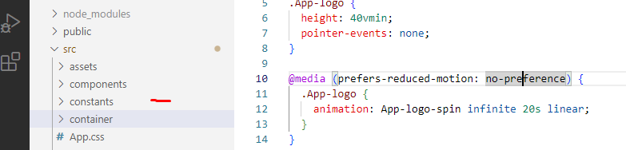

## Structure Folder Container

Then we need fill our folder Container

### About

Inside folder Container, create folder About, then create file About.jsx and About.scss, and fill About.jsx with this

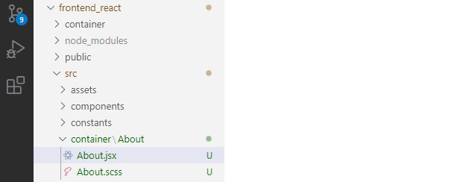

import React from 'react'

import './About.scss'

const App = () => {

return (

<div>About</div>

)

}

export default App

### Footer

Inside folder Container, create folder Footer, then create file Footer.jsx and Footer.scss, and fill Footer.jsx with this

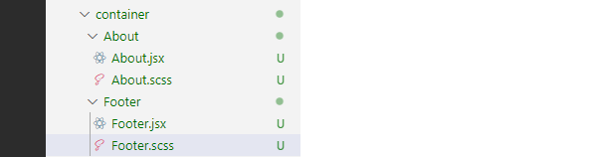

import React from 'react'

import './Footer.scss'

const App = () => {

return (

<div>Footer</div>

)

}

export default App

### Header

Inside folder Container, create folder Header, then create file Header.jsx and Header.scss, and fill Header.jsx with this

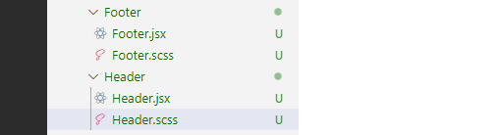

import React from 'react'

import './Header.scss'

const App = () => {

return (

<div>Header</div>

)

}

export default App

### Skills

Inside folder Container, create folder Skills, then create file Skills.jsx and Skills.scss, and fill Skills.jsx with this

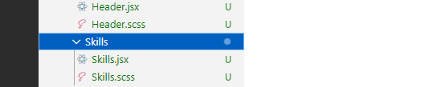

import React from 'react'

import './Skills.scss'

const App = () => {

return (

<div>Skills</div>

)

}

export default App

### Testimonial

Inside folder Container, create folder Testimonial, then create file Testimonial.jsx and Testimonial.scss, and fill Testimonial.jsx with this

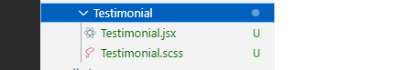

import React from 'react'

import './Testimonial.scss'

const App = () => {

return (

<div>Testimonial</div>

)

}

export default App

### Work

Inside folder Container, create folder Work, then create file Work.jsx and Work.scss, and fill Work.jsx with this

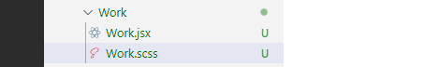

import React from 'react'

import './Work.scss'

const App = () => {

return (

<div>Work</div>

)

}

export default App

### Index

Inside folder frontend_react/src/container, create file index.js, to export our components then fill with this

export { default as About } from './About/About'

export { default as Footer } from './Footer/Footer'

export { default as Header } from './Header/Header'

export { default as Skills } from './Skills/Skills'

export { default as Testimonial } from './Testimonial/Testimonial'

export { default as Work } from './Work/Work'

### App

Inside folder frontend_react/src, in file App.js, fill with this

import React from 'react'

import { About, Footer, Header, Skills, Testimonial, Work } from './container'  
import './App.scss'

const App = () => {

return (

<div className='app'>

<Header/>

<About/>

<Work/>

<Skills/>

<Testimonial/>

<Footer/>

</div>

)

}

export default App

## Structure Folder Components

Then we need fill our folder Components

### Navbar

Inside folder Components, create file Navbar.jsx and Navbar.scss, and fill Navbar.jsx with this

import React from 'react'

import './Navbar.scss'

const Navbar = () => {

return (

<div>Navbar</div>

)

}

export default Navbar

### Index

Inside folder Components, create file Index.js to export our components

export { default as Navbar } from './Navbar/Navbar'

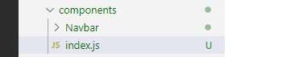

### App

Inside folder frontend_react/src, edit file App.js to import our component

import React from 'react'

import { About, Footer, Header, Skills, Testimonial, Work } from './container'

**import { Navbar } from './components'**

const App = () => {

return (

<div className='app'>

**<Navbar/>**

<Header/>

<About/>

<Work/>

<Skills/>

<Testimonial/>

<Footer/>

</div>

)

}

export default App

### Test Our FrontEnd

npm start

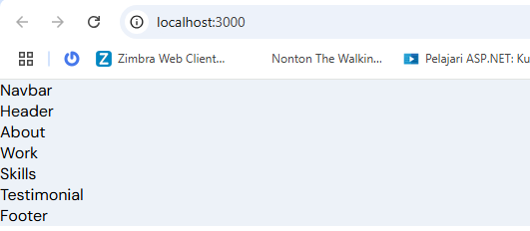

# Navbar

## Images

### Navbar

Then we need edit html semantic tag in Navbar

Enter **frontend_react/src/components/Navbar,** then edit Navbar.jsx

import React from 'react'

import './Navbar.scss'

import { images } from '../../constants';

const Navbar = () => {

return (

<nav>

<div>

<img src={images.logo} alt='logo' />

</div>

</nav>

)

}

export default Navbar

### Assets

Copy asset images from my gitlab

https://gitlab.com/youtube2761319/javascript-mastery/2-portfolio-website.git

## Constant

### Images.Js

Enter **frontend_react/src/constant,** and create file images.js, and fill with this

import email from '../assets/email.png';

import mobile from '../assets/mobile.png';

import api from '../assets/api.png';

import cpp from '../assets/cpp.png';

import css from '../assets/css.png';

import figma from '../assets/figma.png';

import flutter from '../assets/flutter.png';

import git from '../assets/git.png';

import graphql from '../assets/graphql.png';

import html from '../assets/html.png';

import javascript from '../assets/javascript.png';

import mu5 from '../assets/mu5.png';

import node from '../assets/node.png';

import python from '../assets/python.png';

import react from '../assets/react.png';

import redux from '../assets/redux.png';

import sass from '../assets/sass.png';

import typescript from '../assets/typescript.png';

import vue from '../assets/vue.png';

import about01 from '../assets/about01.png';

import about02 from '../assets/about02.png';

import about03 from '../assets/about03.png';

import about04 from '../assets/about04.png';

import profile from '../assets/profile.png';

import circle from '../assets/circle.svg';

import logo from '../assets/logo.png';

import adidas from '../assets/adidas.png';

import amazon from '../assets/amazon.png';

import asus from '../assets/asus.png';

import bolt from '../assets/bolt.png';

import nb from '../assets/nb.png';

import skype from '../assets/skype.png';

import spotify from '../assets/spotify.png';

export default {

email,

mobile,

api,

cpp,

css,

figma,

flutter,

git,

graphql,

html,

javascript,

mu5,

node,

python,

react,

redux,

sass,

typescript,

vue,

about01,

about02,

about03,

about04,

profile,

circle,

logo,

adidas,

amazon,

asus,

bolt,

nb,

skype,

spotify,

};

### Index.Js

Enter **frontend_react/src/constant,** and create file index.js to export our images.js, and fil with this

export { default as images } from './images';

### Test Our FrontEnd

npm start

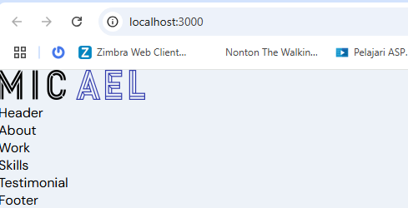

## Component

### Navbar.Jsx

Enter **frontend_react/src/components/Navbar,** and edit file Navbar.jsx, and fill with this

import React, { useState } from 'react';

import { HiMenuAlt4, HiX } from 'react-icons/hi';

import { motion } from 'framer-motion';

import { images } from '../../constants';

import './Navbar.scss';

const Navbar = () => {

const [toggle, setToggle] = useState(false);

return (

<nav className="app__navbar">

<div className="app__navbar-logo">

<img src={images.logo} alt="logo" />

</div>

<ul className="app__navbar-links">

{['home', 'about', 'work', 'skills', 'contact'].map((item) => (

<li className="app__flex p-text" key={`link-${item}`}>

<div />

<a href={`#${item}`}>{item}</a>

</li>

))}

</ul>

<div className="app__navbar-menu">

<HiMenuAlt4 onClick={() => setToggle(true)} />

{toggle && (

<motion.div

whileInView={{ x: [300, 0] }}

transition={{ duration: 0.85, ease: 'easeOut' }}

>

<HiX onClick={() => setToggle(false)} />

<ul>

{['home', 'about', 'work', 'skills', 'contact'].map((item) => (

<li key={item}>

<a href={`#${item}`} onClick={() => setToggle(false)}>

{item}

</a>

</li>

))}

</ul>

</motion.div>

)}

</div>

</nav>

);

};

export default Navbar;

### Navbar.Scss

Enter **frontend_react/src/components/Navbar,** and edit file Navbar.scss, and fill with this

.app__navbar {

width: 100%;

display: flex;

justify-content: space-between;

align-items: center;

padding: 1rem 2rem;

background: rgba(255, 255, 255, 0.25);

// box-shadow: 0 8px 32px 0 rgba( 31, 38, 135, 0.37 );

backdrop-filter: blur(4px);

-webkit-backdrop-filter: blur(4px);

border: 1px solid rgba(255, 255, 255, 0.18);

position: fixed;

z-index: 2;

}

.app__navbar-logo {

display: flex;

justify-content: flex-start;

align-items: center;

img {

width: 90px;

height: 20px;

@media screen and (min-width: 2000px) {

width: 180px;

height: 40px;

}

}

}

.app__navbar-links {

flex: 1;

display: flex;

justify-content: center;

align-items: center;

list-style: none;

li {

margin: 0 1rem;

cursor: pointer;

flex-direction: column;

div {

width: 5px;

height: 5px;

background: transparent;

border-radius: 50%;

margin-bottom: 5px;

}

a {

color: var(--gray-color);

text-decoration: none;

flex-direction: column;

text-transform: uppercase;

font-weight: 500;

transition: all 0.3s ease-in-out;

&:hover {

color: var(--secondary-color);

}

}

&:hover {

div {

background: var(--secondary-color);

}

}

}

@media screen and (max-width: 900px) {

display: none;

}

}

.app__navbar-menu {

width: 35px;

height: 35px;

border-radius: 50%;

position: relative;

display: flex;

justify-content: center;

align-items: center;

background-color: var(--secondary-color);

svg {

width: 70%;

height: 70%;

color: var(--white-color);

}

div {

position: fixed;

top: 0;

bottom: 0;

right: 0;

z-index: 5;

padding: 1rem;

width: 80%;

height: 100vh;

display: flex;

justify-content: flex-end;

align-items: flex-end;

flex-direction: column;

background: url('../../assets/bgWhite.png');

background-color: var(--white-color);

background-size: cover;

background-repeat: repeat;

/* top box shadow */

box-shadow: 0px 0px 20px rgba(168, 168, 168, 0.15);

svg {

width: 35px;

height: 35px;

color: var(--secondary-color);

margin: 0.5rem 1rem;

}

ul {

list-style: none;

margin: 0;

padding: 0;

height: 100%;

width: 100%;

display: flex;

justify-content: flex-start;

align-items: flex-start;

flex-direction: column;

li {

margin: 1rem;

a {

color: var(--gray-color);

text-decoration: none;

font-size: 1rem;

text-transform: uppercase;

font-weight: 500;

transition: all 0.3s ease-in-out;

&:hover {

color: var(--secondary-color);

}

}

}

}

@media screen and (min-width: 900px) {

display: none;

}

}

@media screen and (min-width: 900px) {

display: none;

}

}

### NavigationDots.Jsx

Enter **frontend_react/src/components/,** and create file NavigationDots.jsx, and fill with this

/* eslint-disable jsx-a11y/control-has-associated-label */

/* eslint-disable jsx-a11y/anchor-has-content */

import React from 'react';

const NavigationDots = ({ active }) => (

<div className="app__navigation">

{['home', 'about', 'work', 'skills', 'testimonial', 'contact'].map((item, index) => (

<a

href={`#${item}`}

key={item + index}

className="app__navigation-dot"

style={active === item ? { backgroundColor: '#313BAC' } : {}}

/>

))}

</div>

);

export default NavigationDots;

### SocialMedia.Jsx

Enter **frontend_react/src/components/,** and create file SocialMedia.jsx, and fill with this

import React from 'react';

import { BsTwitter, BsInstagram } from 'react-icons/bs';

import { FaFacebookF } from 'react-icons/fa';

const SocialMedia = () => (

<div className="app__social">

<div>

<BsTwitter />

</div>

<div>

<FaFacebookF />

</div>

<div>

<BsInstagram />

</div>

</div>

);

export default SocialMedia;

### Test Our FrontEnd

npm start

